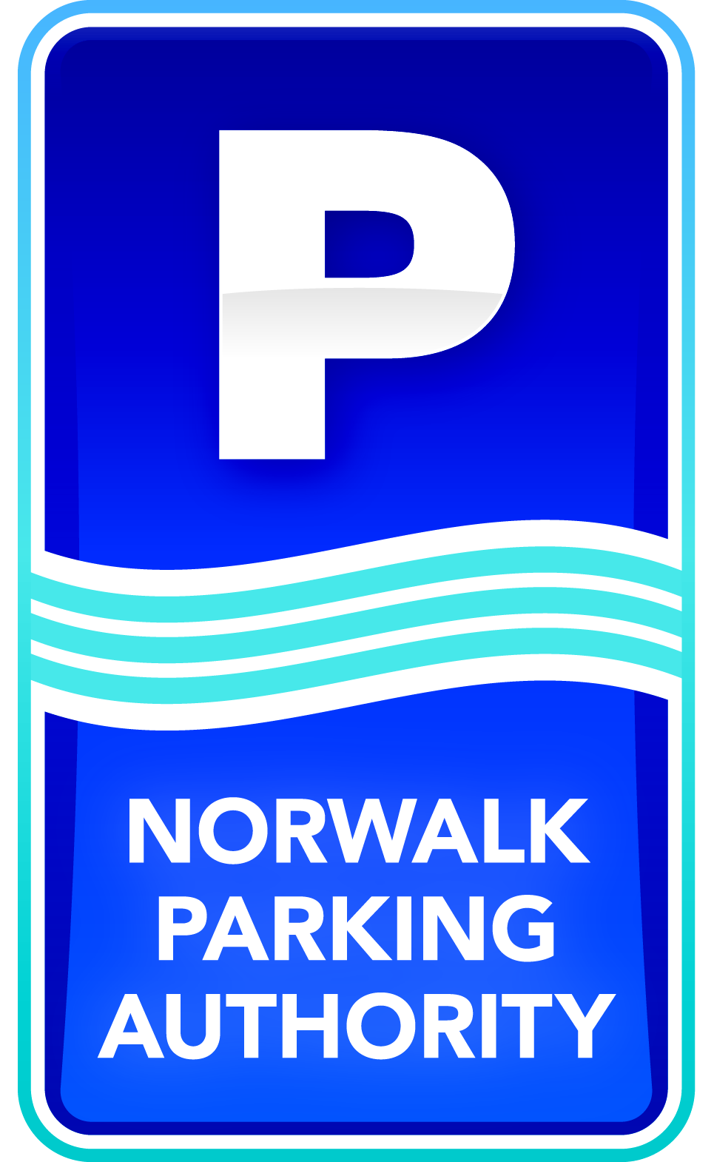

Norwalk Launches First Smart Parking in Connecticut

Norwalk, CT (October 14, 2014) - - Looking for a parking place can be both frustrating and time consuming. In Norwalk, CT, people looking for parking in its urban areas will be the first in Connecticut to be able to find open parking spaces instantly via an app on their smart phones, saving time and improving their parking experience. The Norwalk Parking Authority officially launched the technology in its downtown South Norwalk area on Tuesday, October 14th with Norwalk’s Mayor, Chamber of Commerce President, its technology partners, elected officials from Norwalk and representatives of area businesses and other regional cities present.
The system works via wireless sensors that are embedded in each parking space to detect whether or not the space is occupied. Data from each sensor is relayed via wireless to the cloud and pushed into an easy-to-use app showing real-time parking availability. CASE Parking, a parking data solutions provider, will collect occupancy data from the lots and garages. Streetline, the leading global provider of sensor-based smart parking technology, has outfitted the on-street parking spaces with sensors. Data from both systems will be streamed directly into Streetline's mobile app, Parker™. People can access the Parker™ app via their smart phones, or at www.norwalkpark.org/smartparking.
Earlier this year, the Parking Authority implemented the first phase of its Smart Parking plan with real-time parking availability information at the South Norwalk Railroad Station Garage online at www.norwalkpark.org. This information, as well as other parking facilities such as the Maritime Garage and metered spots, will be integrated into the new smart parking system in the near future.
“Smart parking is a great benefit to cities like Norwalk, providing an easy way for residents and visitors to find a parking spot quickly, get out of their cars and enjoy all that the City has to offer,” says Norwalk Mayor Harry Rilling. “In addition, with people driving around less, smart parking improves congestion and saves on gas making it better for the environment.”
“By staying at the forefront of technology, the Norwalk Parking Authority is improving the parking experience for our customers,” says Julius Hayward, Chairman of the Norwalk Parking Authority. “It is another indication of the Parking Authority’s commitment to efficiently manage parking to support Norwalk as a great place to live, work and visit.”
“We are thrilled to roll out this technology across Norwalk,” said Zia Yusuf, President and CEO of Streetline. “By working alongside Case, we are able to bring real-time parking data for both on- and off-street facilities into the Parker app and offer motorists a comprehensive view of availability, while helping the Authority to manage parking more efficiently.”

ABOUT THE NORWALK PARKING AUTHORITY
The Norwalk Parking Authority is a financially self-sustaining organization responsible for the operation and maintenance of the municipal parking system in Norwalk. It is not financed by taxpayer dollars. The Authority is committed to making Norwalk a better place to live, work and visit by collaborating with community organizations while providing exceptional customer service to parking customers.

For more information on the Norwalk Parking Authority, visit: www.norwalkpark.com

ABOUT STREETLINE, INC.
Streetline is a leading smart parking company delivering smart data and advanced analytics to solve parking issues for customers worldwide. Streetline’s pioneering technology makes the parking experience for consumers easier, while making cities, university and corporate campuses more efficient. Through sound level and road surface temperature sensing capabilities, Streetline helps cities and campuses to further enhance their ‘smart city’ or ‘smart campus’ initiatives. Our vision is simple—to solve parking and make smart cities a reality.
Streetline is a privately held company headquartered in Foster City, CA with smart parking deployments in U.S., Canada, and Europe. The company was named one of Fast Company’s 10 Most Innovative Companies in Transportation, as well as IBM Global Entrepreneur of the Year. Streetline was named Best Mobile Innovation for ‘Smart Cities’ for Parker at the 2013 Mobile World Congress, a Gartner 2013 Cool Company, was recognized with the 2013 Frost & Sullivan North American Competitive Strategy Leadership Award, and in September 2014, was elected to the Intelligent Transportation Society (ITS) World Congress Hall of Fame.

To learn more about Streetline, visit www.streetline.com, and to download the Parker app for iOS and Android, visit http://www.theparkerapp.com.

ABOUT CASE PARKING
CASE Parking delivers 99.9+ percent accurate, real-time occupancy data via its proprietary Counts in the Cloud™ system, enabling effective parking operations management through its fully-integrated web-based dashboard. Through innovative partnerships with leading app developers, parking operators can ultimately increase sales, reduce labor costs and minimize lost revenue, while also assisting drivers to find parking space availability quickly and easily. CASE’s clients and partners—including Streetline, Texas A&M University, ParkMe, University of Hawaii and the City of Newport Beach—rely on CASE Parking’s technology to improve the overall efficiency of their operations.

For more information on CASE Parking solutions, visit www.caseparking.com

FOR MEDIA INQUIRIES, CONTACT:

Norwalk Parking Authority: Carolyn Ripp, cripp@snydergroupinc.com, (203) 852-1261, x107

Streetline, Inc.: Brittany Blasing, press@streetline.com, (650) 242-3447

CASE Parking: Leslie Licano, leslie@beyondfifteen.com, (949) 733-8679

# # #

